**Rocket**

A Platformer Game where the Player controls a Rocket in space by tilting the device side to side, avoiding obstacles, collecting Star Shards and accumulating Score.

**Features**

***Tilt Controls***: The Player controls the Rocket by tilting their device side to side. If they tilt too far and the Rocket goes past the edge of the screen, then it will reappear at the other side of the screen. The Rocket will move continuously in an upward direction until it collides with an Obstacle or the player quits the game.

***Obstacles***: The game will feature two core obstacles which must be avoided to continue progressing:

**Static Obstacles**: These will remain in the same position for the duration of their screen time. The Player must steer the Rocket clear of the obstacle.

**Mobile Obstacles**: These will move at a consistent pace across the screen. The Player has to be quick to steer out of their way.

***Power Ups***: The game will feature some power ups to assist the Player throughout. They will appear infrequently during the game and will have varying effects when collected:

**Laser Cannons**: Allows the Player to fire Projectiles ahead of them, destroying any obstacles they come across. Rather than have a time limit set on them, they will have a set ammo amount, which when depleted, will cause the power up to deactivate.

**Ethereal Dimension Transmitter**: Sends the Player into the Ethereal realm for a limited period of time. Whilst they are in the Ethereal realm they will not collide with any objects in the Material Realm.

**Time Depression Device**: Slows the Player (and everything else in the game) down for a short duration, giving them a longer time to react to any objects in the game.

***Score Counter***: The game’s main focus is to accumulate Score by keeping the Rocket from being destroyed by Obstacles. The longer the Player can do this, the higher a score they will attain. When the Player eventually fails to keep the Rocket from being destroyed, then their final score will be compared against their highest score, effectively making your objective to beat your previous High Score.

***In-game Currency***: When the Player is in-game, small items will spawn, which when collected, will add to their in-game Currency. This Currency can then be used to purchase items in the Store.

***In-game Store***: When the Player is not in-game, they can go to the Store and use their in-game Currency to buy items (Rocket Reskins etc.). Items can only be purchased with the in-game Currency which can only be obtained by playing the game. I have no intention to add the option to use real money.

**Platforms**

Android for the time being since I don’t always have access to an IOS device.

**Audience**

Anyone who can hold a Mobile device in their hands and tilt it.

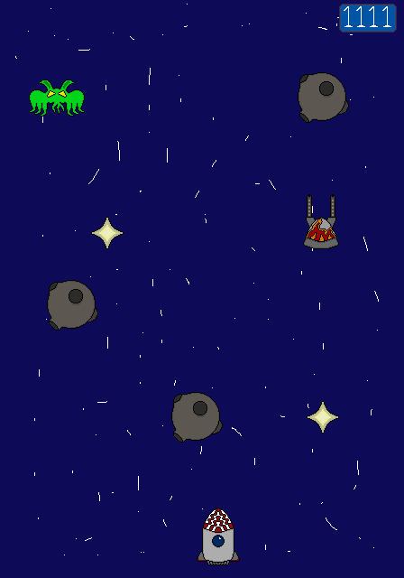**Game Layout**

Collect Stars Shards to buy Items in the Store

Acquire Power-Ups to help you navigate the Dangers of Outer Space

The longer the Rocket can go on its journey, the higher the Score goes

Space Monsters move side to side

Asteroids remain in place bur restrict the Player’s pathway

Steer the Rocket through Space by tilting the Device from side to side. It moves forward on its own

**Interface Layout**

I will upload a prototype soon.

**Art Design**

I will try to design all sprites in a 64 x 64-pixel canvas, giving them a very cartoonish look. In terms of color palette, I was thinking of blending the cold metallic sci-fi look with some very saturated colors.

**Music**

Sci-Fi Music, no question about it.

**Development Strategy**